COURTNEY’S 1950’S ROCK & BOWL BENEFIT

Featuring Houston Elvis
Ralph Elizondo

SHOW YOUR SUPPORT FOR COURTNEY AS SHE FIGHTS SPINAL MUSCULAR ATROPHY
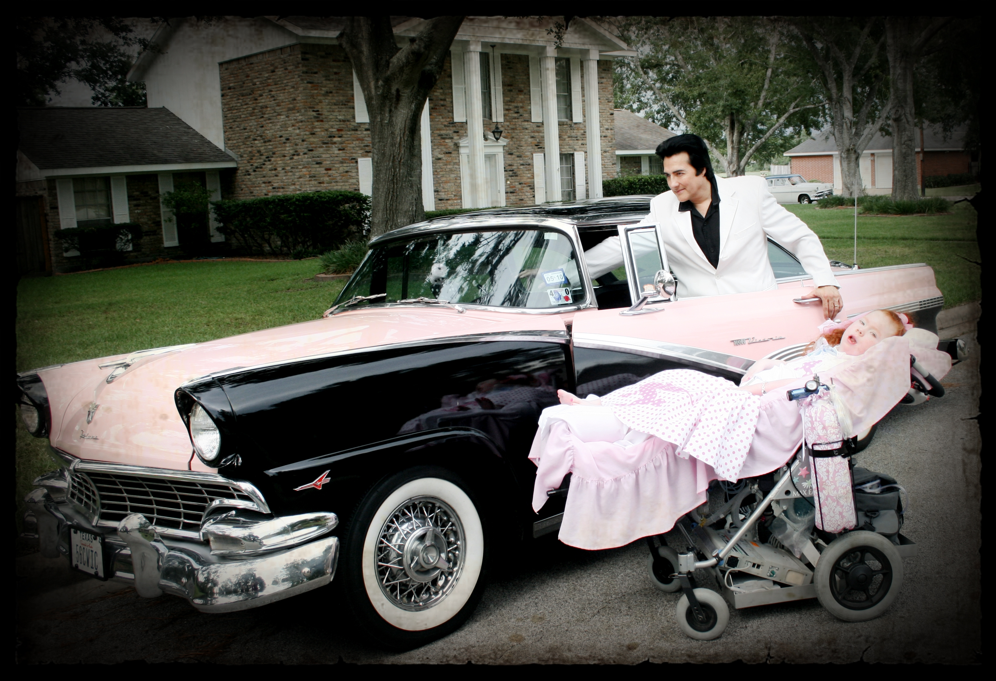

Sunday, October 4th from 4:00 p.m. to 7:00 p.m.
Clear Lake Bowling Lanes
16743 Diana Lane, Houston, Tx. 77062
1950’s Elvis Show at 4:00 p.m.
Door Prizes, 50’s Costume Contest, Bowling, Silent Auction, 50/50 Raffle, and more!!!
Tickets: $15 prepaid or $20 at door (price includes bowling)

ORDER TICKETS ONLINE at www.houstonelvis.com

If you have questions please call 713-779-2783 or 713-946-2457
www.our-sma-angels.com/CourtneyBrooke

