Life with a Trach
by: Margaret “MJ” Purk

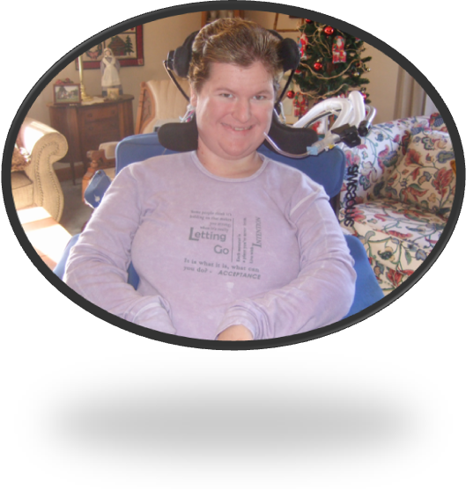
Just to introduce myself, my name is Margaret Purk, but most people call me MJ. I’m 20 years old and am a junior at Wright State University, majoring in Rehabilitation Services. I carry a full load of classes, usually 16 to 18 hours a quarter. I have Spinal Muscular Atrophy, SMA, type I+. The plus basically means that I fit neither the type I category nor the type II category because I have maintained many abilities lost by type I’s and never achieved some of the abilities type II’s have.
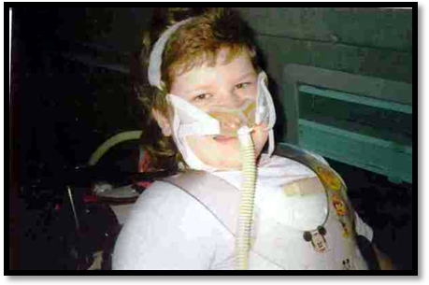
For the last 13 years I have used Noninvasive ventilation (NIV) and enjoyed an amazing quality of life. I started using NIV at age 8 because of significant CO₂ retention and under oxygenation. For the first year I used a BiPAP machine and while the Respiratory Therapist said that it would take awhile for me to adjust, I took to it immediately. After my spinal fusion at age 9, I needed more support so I switched to a volume ventilator to support my nighttime, and eventually daytime, ventilatory needs.
Since 11 years ago my breathing has been changing and unfortunately, not for the better. Due to repeated intubations during my high school years, my epiglottis was damaged which caused breathing to become increasingly difficult. My breathing “space” in my lungs has become increasingly smaller over the years, leaving me with, what one of my doctors refers to as, “teeny tiny lungs”.
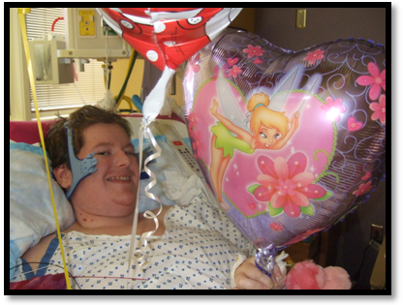
In January of 2008, I developed the flu which ultimately led to my 3rd hospitalization due to illness. I recovered from the flu in about two weeks and then developed a stomach virus which led to more than 36 hours straight of vomiting. After I finally recovered from both the flu and the stomach virus, I was finally able to get up in my wheelchair, with hopes of returning home and to school. Unfortunately, this course of action was not to be, at least not for me.
Every time I would get up in my wheelchair, I quit breathing after 20 minutes. The first time my heart rate also dropped but that didn’t occur again. I had several subsequent episodes of breathing stoppage and they would only occur in my wheelchair. After the initial 20 minutes, my nurse would use the Cough Assist to open my airway again. My airway would repeatedly collapse in 10 minute intervals after the initial 20 minutes sitting up in my chair. After several days of tests; ranging from an EEG to an IPV treatment to a nasal trumpet, it was decided that something needed to be done on a more permanent basis. After many weeks and stomach complications, I was released home with my trach.
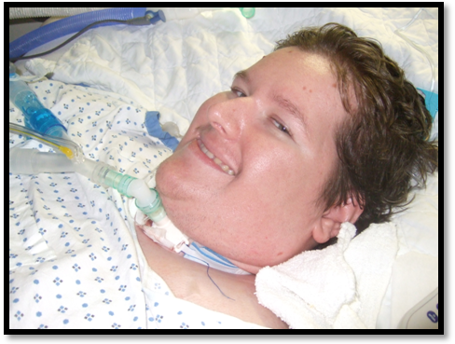
My trach took some getting used to but I am now 4 months out and I have to say that I wish I would have gotten one sooner. Despite a persistent infection, I’m doing great with my trach. I still attend college full-time, with my nurse, Brenda. I have noticed a variety of pros and cons when comparing NIV to trach.
The pros, in my opinion and experience, outweigh the cons but I must confess that I am very new to the world of trachs so I can’t say for certain that I won’t find more cons along the way. One of the biggest benefits for me is that I no longer have to be actively trying to breathe. Prior to my trach I used a mouthpiece during the day, which required me to be attentive to my breathing. Like many young adults, I don’t always do as I should so remembering to use my vent was a bone of contention between myself and my medical team. I also no longer get what many people refer to as BiPAP bites or pressure sores from the mask. My face is “naked” all the time now. Another smaller very shallow benefit is that people don’t seem to notice my trach as much as they did my mouthpiece set up. I wasn’t hugely self conscious about that but occasionally it would bother me. The greatest benefit I have found thus far is the trach in combination with the Cough Assist. I find it a great deal easier to get plugs out now. Plugs that used to take two to three hours to get out, now take a maximum of fifteen minutes to clear.
The cons really depend on a few things; 1) who is caring for the trached individual, 2) how well the trached individual and caretaker adjust to the trach and 3) the lifestyle that both the trached individual and caretaker were accustomed to prior to the trach. For me, Brenda is, was, and will continue to be my primary caretaker so we both adjusted together. When we attempted to add other individuals into my daily care routine, it didn’t work out so well. My father also did well with trach care and caring for me, despite not being my primary caregiver for many years now. As I said before, I adjusted well to my trach, minus a persistent infection I acquired in the hospital. The infection, pseudomonas, is quite common for people with trachs. I was so darn lucky that I had this infection three times prior to getting my trach. My lifestyle hasn’t changed too much but enough so that I can tell a difference. I require a great deal more suctioning than I did before but that could be due to my infection. I am more “attached” to Brenda because of this and, right now, can’t go running off on my own. I don’t mind that as much as I thought I would; Brenda gives me my space and I don’t miss out on anything because of my trach.
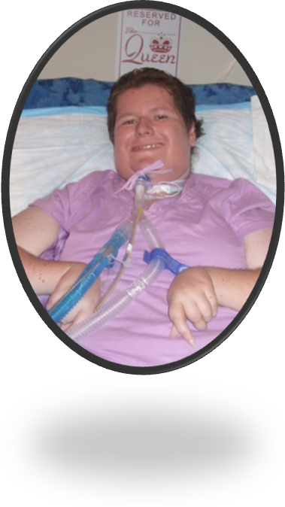
I am still a big supporter of NIV despite now using a trach. NIV got me through some very hard years and I owe my life to it. Do I wish I could go back in time and have been trached sooner? Sometimes, but there are always things everyone wishes they could change. I truly believe that it is a huge success that I made it 20 years before needing a trach. Ultimately, each person or family must decide on the path that works best for them. I’m just one person who has lived with NIV and now trach. My experiences with both are unique to me, I had hoped I’d never need one but I will never regret any of the medical choices I have made.

