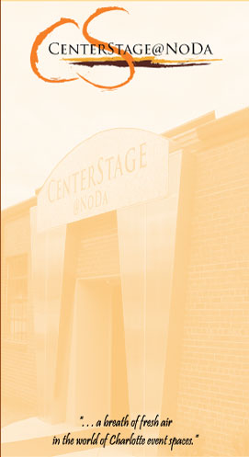
1st Annual Expect Miracles Ball

Saturday, November 3rd, 2007

Center Stage @ NoDa

dinner by the Harper’s Restaurant Group

music featuring “Timeless”

Tickets: $75.00 per person
$750.00 for a reserved table for 10
(If you are buying a table for 10, please write all attendees
names on the back of this form so we have them at the door)

Name: ___________________________________________

Address: ___________________________________________

___________________________________________

Phone: ___________________________________________

Email: ___________________________________________

# people: _________

Amount Enclosed: _________

Please make checks out to “FSMA” for dinner reservations. Any other donations, please make checks out to “For the Love of Jake Fund”.
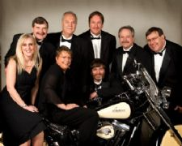
Please mail back reservations to:

“For the Love of Jake”
Expect Miracles Ball
1209 Golden Hill Road
Matthews, NC 28105

by October 15th, 2007

